**Timeline**

Next Friday (27 March 2020, 2359) submit design report

~~Next Monday (23 March 2020), watch lectures before hand so that we can spend the workshop time effectively~~

~~Next Wednesday (25 March 2020), prepare presentation~~

8 April Week 12, Final Report is due. There will be peer review. (Optional: upload on Wednesday 10 April for tutor feedback)

20 April 2020, Final report submission is due.

**Deliverable 1: Final Design Report**

Major difference: Section 4 becomes 4,5,6

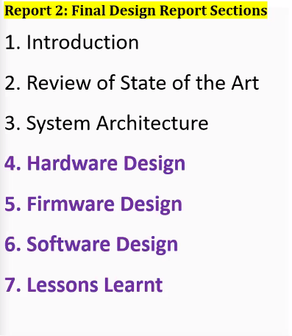

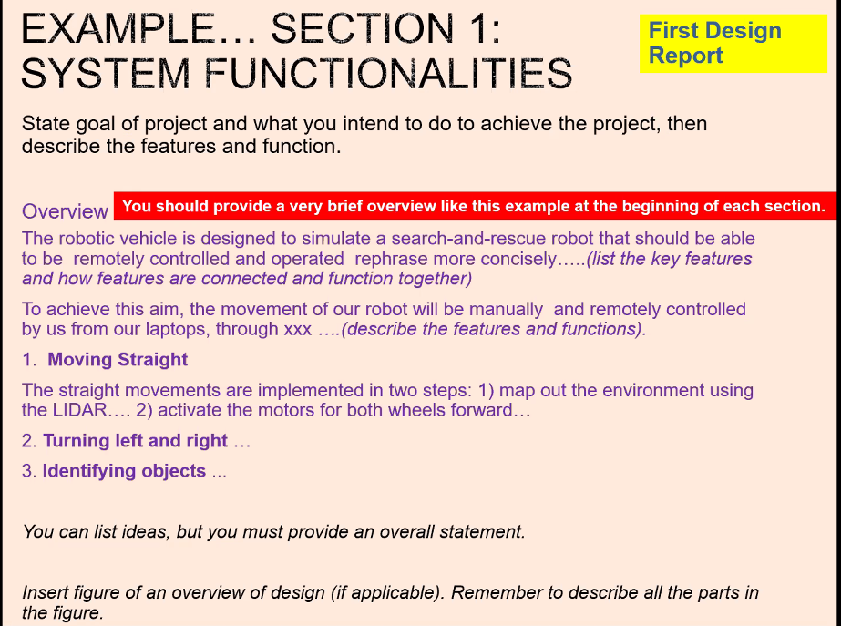

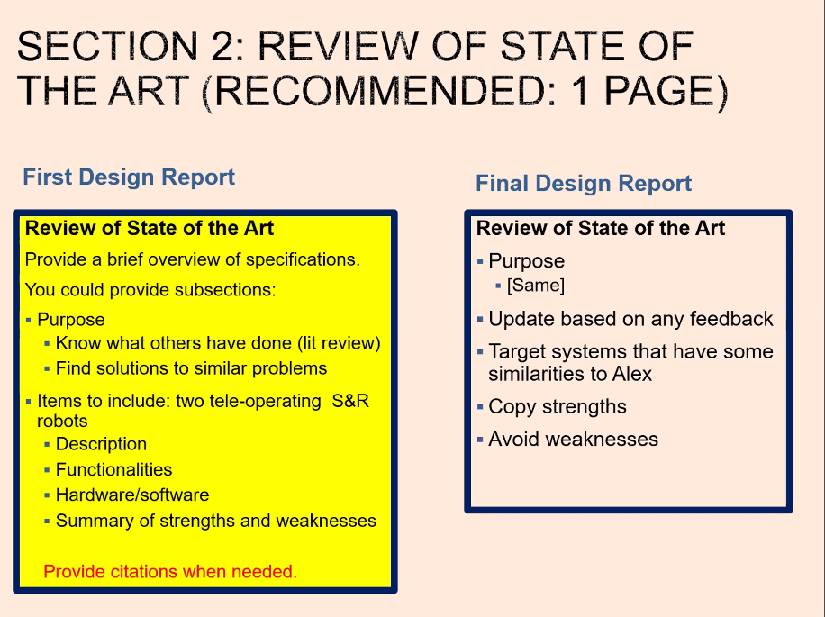

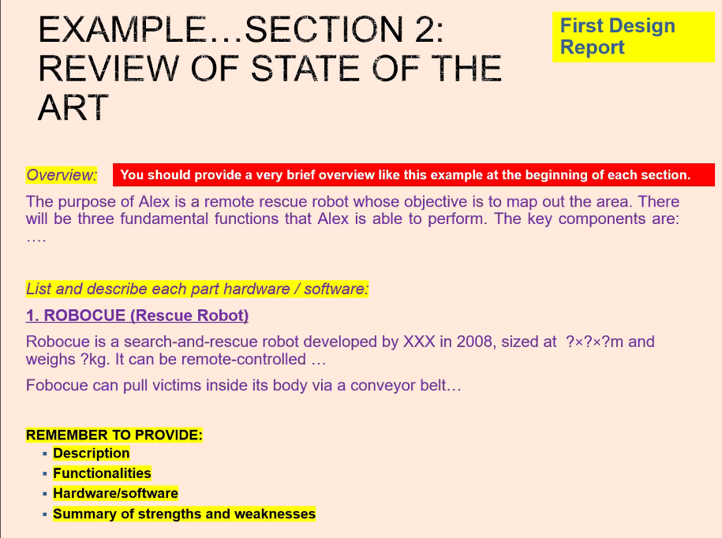

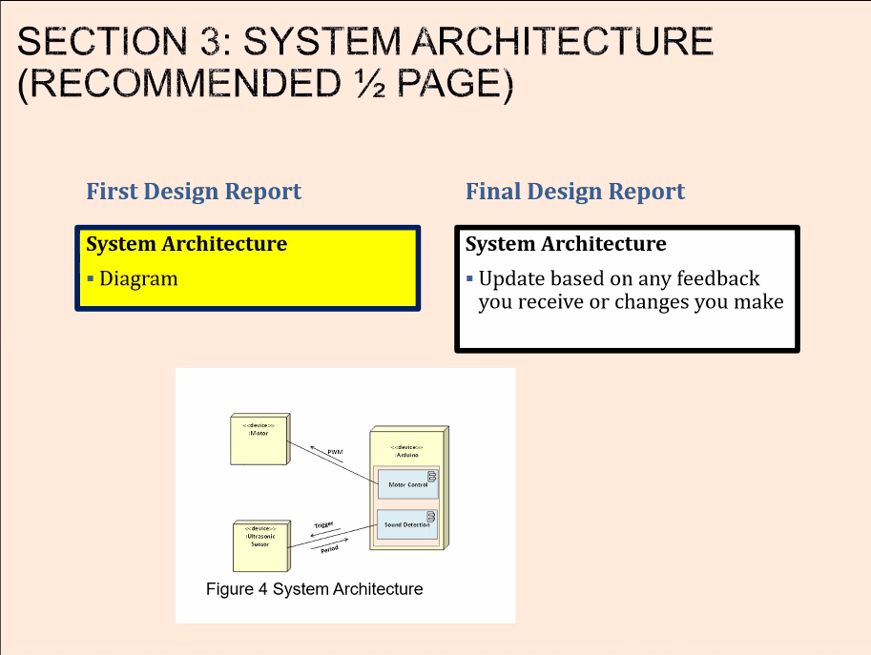

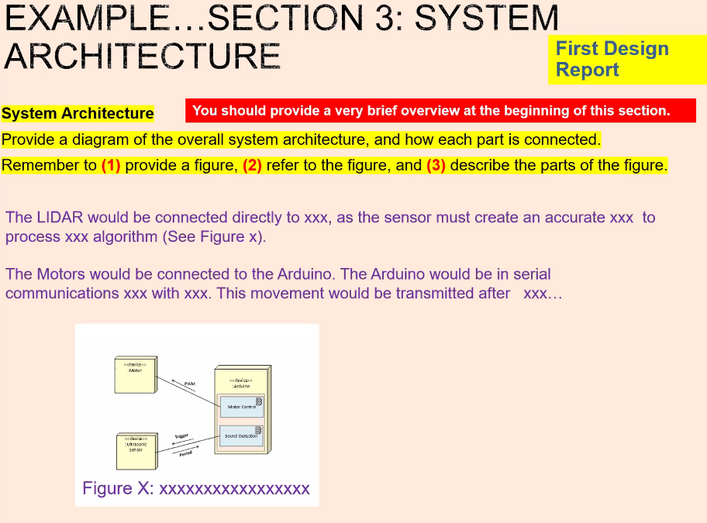

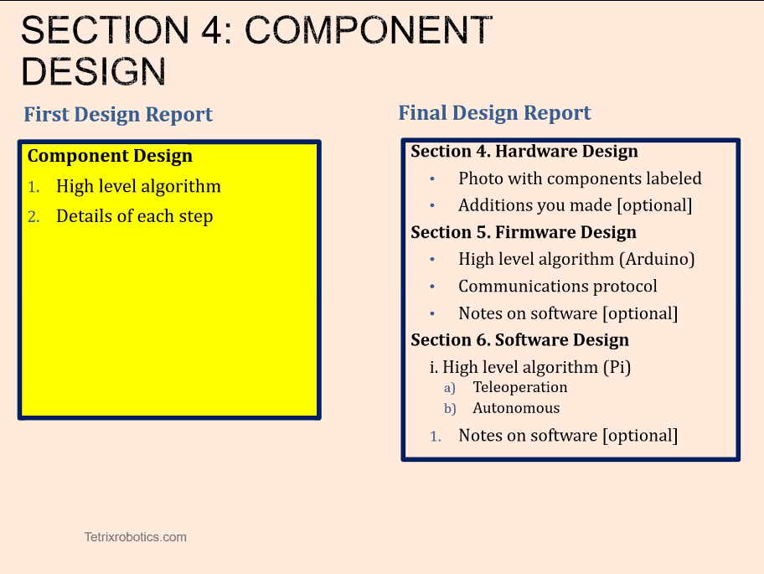

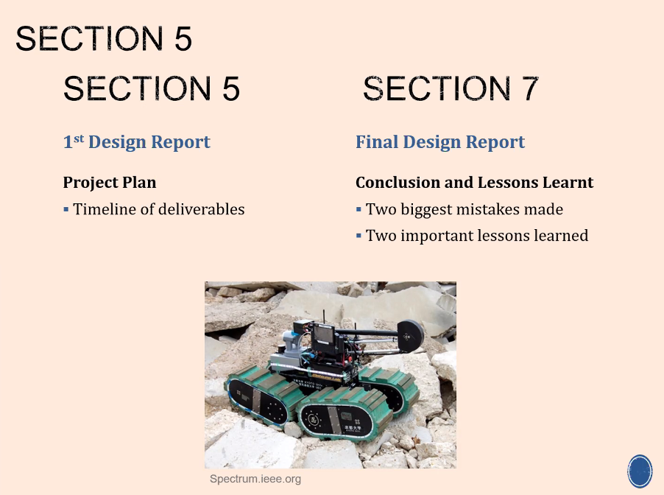

Things to note:

1. In lists, keep subjects the same: e.g. alex will, alex will, alex will instead of alex will, reduce of alex, create for alex.
2. Modifiers, “only” need to come right after the thing that it is modifying

Contact details:

Ms Sunita, 98515075, elcsn@nus.edu.sg